

Data-Driven Prediction of Local Government Water Service Delivery Outcomes through Machine Learning

N Hlumbene
Research Study submitted for the degree Honours in Computer Science & Information Technology at the North-West University (Vanderbijilpark Campus)

Supervisor: Prof Imelda Smit
Student number: 42452422

Abstract
The persistent failure of South African municipalities to deliver reliable water services remains a significant governance challenge despite the existence of legislative frameworks such as the Municipal Finance Management Act (2003) and oversight mechanisms administered by the Auditor-General of South Africa. Traditional audit-based accountability systems have proven insufficient at identifying municipalities at risk of service delivery failure before communities are materially affected, largely because they assess financial compliance retrospectively rather than predicting operational risk proactively. This study addresses a contextual gap in the literature by applying machine learning to predict water service delivery outcomes in South African municipalities using publicly available financial data.

A dataset comprising 3,375 records spanning 292 municipalities across 14 financial years from 2012 to 2025 was constructed by merging four categories of municipal financial data sourced from the Municipal Money portal, which aggregates verified records from the Auditor-General of South Africa and the National Treasury. Following data cleaning, KNN imputation and feature engineering, three supervised machine learning algorithms were trained and evaluated under a positivist research paradigm: Decision Tree, Logistic Regression and Random Forest.

The Random Forest classifier emerged as the best performing model, achieving an accuracy of 91.7%, an F1-score of 0.940 and a ROC-AUC of 0.967, with consistent five-fold cross-validation results confirming the reliability of these findings. SHAP interpretability analysis revealed that municipality identity, sustained irregular expenditure trends over multiple years and a general temporal deterioration in municipal financial governance were the strongest predictors of poor water service delivery outcomes.

The findings suggest that machine learning may offer a meaningful complement to existing audit-based monitoring systems by enabling earlier identification of financially at-risk municipalities. While the study acknowledges that the target variable was constructed from financial governance indicators as proxies for service delivery outcomes rather than direct operational measurements, it may nonetheless contribute a methodological foundation for future data-driven approaches to water service delivery oversight in the South African local government context.

Table of Contents
Abstract 1
List of Tables 5
List of Figures 6
Abbreviations 7
CHAPTER 1: INTRODUCTION 8
1.1 Introduction 8
1.2 Concepts Central To Study 8
Operational Infrastructure Risk and Water Service Delivery 8
The Gap in Compliance Performance and Audit Outcomes 9
Binary Classification with Supervised Machine Learning 9
K-Nearest Neighbours Imputation 10
SHapley Additive exPlanations 10
1.3 Problem Statement 10
Justification for the Proposed Study 11
Research Aim and Objective(s) 11
Research Question(s) 12
1.4 Research Methodology and Design 12
Research Paradigm 12
Research Methodology 13
Machine Learning Life Cycle 14
Project scope 15
Project Limitations 15
Risk Mitigation Matrix 15
Software Resources and Development Platform 16
1.5 Ethical Considerations 16
Upholding Data Integrity and Usage 17
Protecting Personal Information 17
1.6 Study Overview 17
1.7 Conclusion 18
Chapter 2: Research methodology 19
2.1 Introduction 19
2.2 Research Paradigms 21
2.3 Research Methodology 22
2.4 Research Methods 24
2.4.1 Step 1: Data Collection 25
2.4.2 Step 2: Data Preprocessing 25
2.4.3 Step 3: Machine Learning Model Design 25
2.4.4 Step 4: Training and Evaluation 25
2.4.5 Step 5: Visualisation and Interpretability 25
2.6 Conclusion 26
CHAPTER 3: LITERATURE REVIEW 26
3.1 Introduction 26
3.2 Machine Learning as a Predictive Tool in Public Service Delivery 27
3.3 Water Service Delivery Status and Challenges in South Africa 28
3.4 The Relationship Between Clean Audit Outcomes and Actual Service Delivery 30
3.5 How will the literature guide my study? 31
3.5.1 Guiding the Technical Design and Algorithm Selection 31
3.6 Conclusion 32
Chapter 4: Empirical Study 33
4.1 Introduction 33
4.2 Experimentation Design 34
4.2.1 Prediction Model Architecture 34
4.2.2 Target Variable Operationalisation 35
4.2.3 Input Feature Matrix and Selection Reasoning 35
4.2.4 Algorithmic Implementations and Hyperparameter Tuning 36
4.3 Data Preparation and Refinement 37
4.3.1 Data Collection 37
4.3.2 Data Cleaning 38
4.4 Experimentation Conducted (ML Implementation) 40
4.4.1 Data Partitioning 40
4.4.2 Algorithm Training 41
4.4.3 Hyperparameter Tuning 42
4.5 Analysis of Results and Trustworthiness 42
4.5.1 Performance Metrics 43
4.5.2 Trustworthiness 44
4.5.3 SHAP Interpretability 44
4.6 Findings 47
4.6.1 Model Performance 47
4.6.2 Risk Factors 48
4.7 Conclusion 48
CHAPTER 5: CONCLUSION 50
5.1 Introduction 50
5.2 Overview of Research Journey and Achievement of Objectives 51
5.2.1 Evaluation of Research Questions 51
5.3 Research Contributions 53
References 55
Appendix A 57
Appendix B 58

List of Tables
Table 1 Risk Mitigation Matrix 15
Table 2 Algorithm Performance Metrics 43

List of Figures
Figure 1 ML Life Cycle 14
Figure 2 Study Overview 17
Figure 3 Chapter 2 Overview 20
Figure 4 ML Pipeline Flowchart 24
Figure 5 Raw municipal data as presented on Municipal Money website 37
Figure 6 Code for removing data leakage 39
Figure 7 Code for feature engineering 40
Figure 8 Code for training the algorithms 42
Figure 9 Model Evaluation 44
Figure 10 SHAP summary 46
Figure 11 SHAP bar graph 47

Abbreviations
AGSA Audit General South Africa
ML Machine Learning
AI Artificial Intelligence
KNN K-Nearest Neighbours
SHAP SHapley Additive exPlanations
WSA Water Services Act
DWS Department of Water and Sanitation
ROC-AUC Receiver Operating Characteristic – Area Under the Curve

CHAPTER 1: INTRODUCTION

Introduction
The local government in South Africa plays an important role in ensuring that communities receive essential public service delivery such as water allocation, electricity and waste collection. To ensure and improve accountability and transparency in governance, frameworks such as the White Paper on Local Government and the Municipal Finance Management Act were introduced in 1998 and 2003, but despite this poor service delivery still persists (Phumlani et al., 2025:116). Conducting annual municipal audits was also introduced for the same purpose but audit outcomes often do not reflect the actual lived reality of many communities. An example of this is communities such as the Midvaal being able to achieve clean audits while their community still remains without the proper service delivery (Khasodi et al., 2023:338). This suggests that there are structural weaknesses in governance at play (S Mnguni, 2022:153).

This study proposes to address these gaps using supervised machine learning techniques to predict water service delivery outcomes. By making use of audit data with operational indicators, a predictive model has the potential to uncover risk factors that the local government’s traditional systems may be overlooking. The primary aim is to evaluate whether the machine learning models can forecast service delivery failures to support data-driven decision making in the local government. Therefore, this study contributes to the underexplored research in the usage of machine learning and data analysis to predict water service delivery outcomes in the South African local government and also respond to the limitations of the current frameworks being used.

The remainder of this chapter will outline the Concepts Central To Study, Problem Statement, Research Methodology and Design, Ethical Considerations and the Study Overview.

Concepts Central To Study
This section briefly discusses the key concepts related to this study and an overview of related studies.

1.2.1 Operational Infrastructure Risk and Water Service Delivery
Water service delivery is a constitutional standard that has to be maintained by the local government, given that is forms part of the acting Water Service Authorities which are responsible for providing safe and continuous potable water for domestic purposes and institutions (Ishola et al., 2025:76). The municipalities are also obligated by the Water Services Act 108 of 1997 and Section 27(1)(b) of the Constitution of the Republic of South Africa to ensure water service delivery conforms to the national safety standards while simultaneously maintaining low health risk profiles during regulatory assessments conducted through frameworks such as Blue Drop Risk Rating (Ishola et al., 2025:81).

Water service delivery performance is primarily measured using three dimensions, namely quality compliance, service delivery continuity and quantity or access of water. Therefore operational risk factors increase when vulnerabilities such as losing high amounts of water from damaged pipes are the cause of persistent water interruptions, especially when they last for two days or more. This results in public protests when the well being of the affected communities being negatively impacted (Mamokhere, 2025:38; Nodipha et al., 2025:1372; Seema et al., 2025:4).

The Gap in Compliance Performance and Audit Outcomes
According to the Public Audit Act 25 of 2004 and the Municipal Finance Management Act 56 of 2003, organisations such as Auditor-General South Africa (AGSA) are supposed to publicly release annual regulatory assessments known as audit outcomes (S Mnguni, 2022:154; Sambo, 2019:201). Then there also exists a researched phenomenon in South Africa referred to as the “compliance gap” which refers to municipal audit results that do not match or forecast its actual service delivery performance (Khasodi et al., 2023:338). AGSA audit outcomes are considered an administrative compliance measure rather than a representation of operational quality indicators because they evaluate accounting regularity, supply chain compliance and financial reporting accuracy (Khasodi et al., 2023:338; S Mnguni, 2022:156). Therefore, this suggests that traditional auditing frameworks may be overlooking the underlying operational risk factors which allows municipalities obtain clean audits that are false while communities are negatively impacted by poor water service delivery (Khasodi et al., 2023:340).

Binary Classification with Supervised Machine Learning
Machine Learning (ML) is a subfield of Artificial Intelligence (AI) whereby computer algorithms are trained to learn mathematical predictive functions. During the training, a labelled historical dataset is used as input features for the algorithm. For this study, the supervised ML has the potential to change traditional administrative governance into proactive forecasting that can be used for better decision making (Obunga et al., 2025:732).

K-Nearest Neighbours Imputation
K-Nearest Neighbours (KNN) Imputation is a technique used during data preprocessing to fill in missing records in a multidimensional dataset (Hirko et al., 2026:18). This ensures that incomplete municipal records do not get deleted to avoid the occurrence of geographical bias or increased statistical power. This technique is important for this study because real-world datasets often contain missing values that may be a result from inconsistent record keeping (Ishola et al., 2025:80).

SHapley Additive exPlanations
SHapley Additive exPlanations (SHAP) is a technique used to measure how each individual feature contributes to a model prediction. In the context of this study, SHAP analysis can convert difficult model outputs into comprehensible risk ranking that can be interpreted by non-technical people. This has the potential to reveal what poor water service delivery outcomes are most driven by (Hirko et al., 2026:29).

Problem Statement
Section 27(1)(b) of the Constitution of the Republic of South Africa and the Water Services Act (WSA) 108 states that the South African local government is obligated by these laws to deliver safe and good quality water to all communities, while AGSA is one of the primary organisations responsible for enforcing financial accountability and regularity over all municipalities. Despite these frameworks being implemented, water service delivery outcomes in South Africa have been declining for many years. Communities are constantly experiencing recurrent water supply interruptions, decaying infrastructure, non-revenue water loss and an increase in public protests. Most of these effects stem from the problem of compliance and performance gap between what audit outcomes reveal and the actual lived lives of community members affected (Mofokeng et al., 2025:6). Therefore, it is possible for a municipality to present good audit outcomes while experiencing underlying risk factors such as neglected asset maintenance and load shedding with electricity.

This suggests that traditional frameworks lack the ability to proactively support decision-making in the local government in a manner that synthesises financial compliance indicators with operational risk indicators. Therefore, the application of ML algorithms has the potential to expose the underlying risk factors that contribute to poor water service delivery. Thus far they have been successfully applied in fields such as healthcare and environmental engineering while their application to forecast service delivery in the local government remains underexplored (Igbokwe & Nwamekwe, 2025:14). Furthermore, this might decrease the number of vulnerable communities that have been persistently enduring poor water service deliveries.

Justification for the Proposed Study
Combining the traditional municipal auditing systems with more proactive and early-warning forecasting might enable local government decision makers and the Department of Water and Sanitation (DWS) are able to identify municipalities that are at high risk before water service delivery collapses. This will allow decision-makers to plan accordingly for targeted resource allocation and prevent unnecessary maintenance that could result from poor service delivery occurrences.

This study also proposes to bridge the gap between public sector management and computer science by modelling that the publicly available municipal datasets can be merged using techniques such as KNN imputation and binary classification to create a predictive model, while SHAP analysis can be used for converting ML outputs into actionable governance insights for users (Igbokwe & Nwamekwe, 2025:15).

Research Aim and Objective(s)
This study’s aim is to compare three supervised ML algorithms and evaluate whether they can accurately forecast water service delivery outcomes using publicly available municipal datasets.

Theoretical Objectives:
- T-OBJ1: Analyse existing literature on municipal water service delivery problems, the constitutional responsibility for water supply and the effects poor water service delivery outcomes have on the communities affected.
- T-OBJ2: Review the documented compliance gap between audit results and actual service delivery performance.

Empirical Objectives:
- E-OBJ1: Conduct data collection, cleaning and preprocessing on municipal datasets using KNN imputation and z-score standardisation.
- E-OBJ2: Select three supervised ML algorithms to train and hyperparameter tune using 70% training and 30% testing dataset.
- E-OBJ3: Compare the three selected supervised ML algorithms against each other based on performance.
- E-OBJ4: Identify the municipal risk factors that contribute to poor water service delivery outcomes by applying SHAP analysis and evaluate whether the predictive insights can be used to improve governance decision-making.

Research Question(s)
This study’s main research question is:

How can binary classification using supervised machine learning algorithms be implemented to predict local government water service delivery outcomes using municipal audit datasets?

Sub-questions:
- RQ1: Which municipal repository should be selected for the appropriate dataset that can be pre-processed using KNN imputation to identify risks associated with poor water delivery outcomes?
- RQ2: How do the three selected supervised ML algorithms compare based on predictive performance and accuracy?
- RQ3: Which factors contribute the most to poor water service delivery outcomes according to SHAP analysis results?
- RQ4: How can the insights from the predictive modelling contribute to the local government’s decision-making?

Research Methodology and Design
This section discusses the selected research for this study and justifies it, research methodology, data processing pipeline and system life cycle applied to the predictive ML model.

Research Paradigm
A research paradigm is a framework that can be used by the researcher as a guide to interpret reality and also generate knowledge. In considering the appropriate research paradigm for this study, it was important to acknowledge the range of paradigms that guide information systems and applied computer science research. The researcher had the option to select between four paradigms, namely: Positivism, Critical Social Theory, Critical Realism and Interpretivism (Goede).

Positivism was chosen as the guiding paradigm for this study because its focus is on designing machine learning models to predict water service delivery outcomes. This is a quantitative task that requires structured data, statistical testing and measurable results. Positivism supports replicable and generalisable findings which fits well with the use of publicly available audit and service delivery datasets. Machine learning also relies on measurable variables and statistical inference, making positivism the most compatible approach. Other paradigms like interpretivism, critical social theory and critical realism provide useful insights into governance and social dynamics but they don’t align directly with the technical goal of predictive modelling.

Research Methodology
This study follows a quantitative empirical research methodology to align with the selected Positivism paradigm. This methodology uses secondary numerical data that is structured and collected from https://municipaldata.treasury.gov.za/ which is a verified government repository for municipal audit datasets. This approach ensures that scientific objectivity is enforced by ensuring the resulting predictive model is grounded only based on computed mathematics and not the researcher’s opinion.

For the task of predicting whether a municipality may be at risk of poor water service delivery, three supervised ML algorithms will be implemented and compared. They are Decision Trees, Logistic Regression and Random Forest and were selected based on their relevance to classification tasks, their use in comparable predictive studies in African and developing-world contexts and the potential they have to be interpretable to non-technical users in municipal governance settings. The Decision Trees algorithm is a transparent prediction mechanism, it presents the model's logic as a series of conditional rules that can be visualised and explained with no advanced technical knowledge.

This might be an advantage in the local government where it is important for the users to understand and interpret not only what the model predicts, but why. The Logistic Regression algorithm is a statistically grounded baseline model that works well with binary classification tasks. It offers coefficient outputs that are interpretable and can indicate the direction and strength of each relationship a predictor has with the outcome variable. A Random Forest algorithm is an extension of the Decision Trees algorithm. It ensembles trees trained on a random subset of the data, which may produce more accurate and robust predictions than a single decision tree, particularly in a dataset such as municipal data with complex interactions between features (Hirko et al., 2026:18; Sylvain et al., 2025:2).

The classification task will have a binary indicator as a target variable and it will indicate whether or not a municipality is likely to experience poor water service delivery outcomes. Operationalising this target variable will require careful consideration of what threshold should define "poor" performance, which may be based on the frequency of water interruptions, the proportion of households with reliable access to water or some composite index derived from available indicators. The study will aim to use the most meaningful and defensible definition that the available data supports.

Machine Learning Life Cycle
For the empirical study a step by step ML data life cycle is followed:
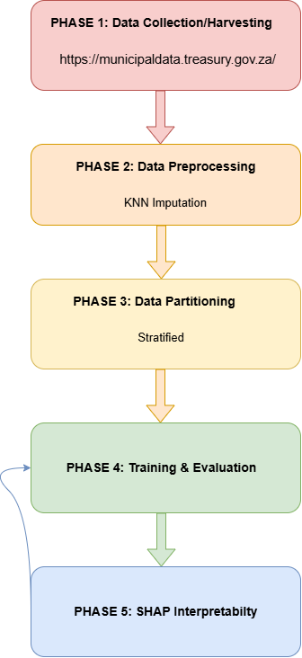
Figure 1 ML Life Cycle

Project scope
- The geographic and administrative boundary of the project includes 292 municipalities that range from metropolitan, local and district under the local government sphere across all nine South African provinces.
- The dataset used covers a multi-year long term window that spans from 2018 to 2024 of annually captured reports and performance cycles.
- The technical scope includes a binary classification for forecasting water service delivery outcomes and their performances, using Decision Trees, Logistic Regression and Random Forest algorithms with SHAP analysis applied for interpretation.

Project Limitations
- The model is dependent on secondary administrative data that is only published annually on regulatory reporting cycles rather than data that can be accessed on real time demand.
- To preserve longitudinal consistency, dataset aggregation was necessary due to municipal mergers and boundary realignments during the study period.

Risk Mitigation Matrix
Potential project risks were identified with mitigation strategies to maintain technical and methodological uncertainties:

Table 1 Risk Mitigation Matrix
Risk Description | Severity | Likelihood | Impact Area | Mitigation Strategy
Missing values in the municipal dataset due to unstable administration and record keeping. | High | High | Data Quality | Apply KNN Imputation to eliminate features with missing values
Poor performing municipal cases being under represented compared to more acceptable cases | High | Medium | Model Bias | Split data between 70% and 30% for training and testing purposes then apply then conduct evaluation using ROC-AUC and F1-Scores.
Algorithmic Overfitting | Medium | High | Generalisation | Set minimum leaf samples and constrain tree depth and execute a 5 fold cross validation.
Falling behind | Medium | Medium | Project Completion | Maintain a schedule that is milestone driven and request supervisor feedback regularly.

Software Resources and Development Platform
The development of the prediction model was an open source data science software technical stack chosen because it eliminates software licensing costs. It also provides for seamless integration for completing the ML life cycle (Mofokeng et al., 2025:3).

- The programming language that was selected is Python because of its sophisticated ecosystem of machine learning frameworks it offers and libraries for data manipulation. It also offers a lot of support in terms of model interpretation tools.
- Jupyter Notebook was selected for the model because of its interactive and user friendly coding environment and also its provision for reproducible generation of documentation.
- Microsoft Excel was used for data analysis prior to the ML life cycle phase of the project.
- The main libraries that were used include pandas and numpy for data ingestion, feature encoding and data merging, scikit-learn for data partitioning, KNN imputation, cross validation and implementing the supervised ML algorithms and matplotlib for plotting ROC-AUC curves, SHAP charts and confusion matrices.

Ethical Considerations
Although this study relies on publicly available data rather than data collected directly from individuals, several ethical considerations remain relevant. The study will ensure that all data used has been sourced from legitimate and publicly accessible platforms and that no personally identifiable information is incorporated into the analysis. The study acknowledges that predictive models carry inherent risks of misclassification and that the outputs of the model should be communicated as probabilistic indicators rather than definitive assessments of municipal performance. The research will be conducted in compliance with the ethical guidelines of North-West University and the broader principles of responsible research practice. The repository for the dataset used is available at: https://municipaldata.treasury.gov.za/. A signed ethics form is also included in this document as an appendix.

Upholding Data Integrity and Usage
- During the completion of this study, none of the raw data will be fabricated, falsified or altered to enforce false results. Any preprocessing techniques such as KNN Imputation and standardisation of z-scores will be executed in coding pipelines that are documented and mathematically objective (Ishola et al., 2025:80).
- NWU Harvard citation formats were used to acknowledge all open source software libraries and data sources.

Protecting Personal Information
South Africa has a law that protects data and how its regulated and maintained. This law is called Protection of Personal Information Act (POPIA Act). The data used in this study and for modelling does not contain any individual citizen records or any Personally Identifiable Information (PII). The dataset includes municipal institutional records that are publicly available in online repositories. This study also has no privacy infringement because it poses zero risks of individual privacy or identity violations. Therefore, no household record, individual citizen or local government employee data was collected, processed or stored for this study (Ngcobo, 2025:77).

Study Overview

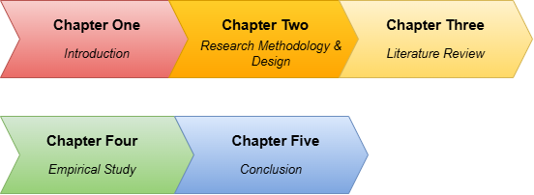
Figure 2 Study Overview

Conclusion
In conclusion, this chapter discussed and introduced the theoretical and methodological concepts that cover the concepts related to using supervised machine learning algorithms as a predictive method for water service delivery outcomes in the local government. It started by discussing the local government’s important role in continuously providing citizens with safe and good quality water. Then it highlighted how poor water service delivery is still persistent in most communities despite the existence of frameworks implemented to promote transparency and accountability in governance.

Furthermore, the chapter discussed the identified compliance gap that exists between the government’s audit results and the actual service delivery communities receive, then to address this gap, the research aim, questions and objectives were discussed. To elaborate on the study’s research methodology, the selected paradigm which is Positivism was discussed and justified with the machine learning life cycle introduced to aid in justifying the chosen research methods. Lastly, the project plan was discussed along with the ethical considerations for the research and an overview for this study. Therefore, this study continues to Chapter 2 where the research methodology will be discussed in depth with the selected Positivism paradigm, research methods and the study’s empirical framework.

Chapter 2: Research methodology

2.1 Introduction
In this chapter the empirical objectives of this study of designing a predictive model for forecasting water delivery outcomes will be addressed by outlining the methodology that will be required to implement a Machine Learning model for water service delivery in the local government. This model must be able to identify factors that contribute to poor water service delivery while also forecasting events that could result in poor service delivery outcomes so they can be minimised. The designing of this model includes incorporating municipal data in the model in order to forecast water service delivery outcomes while following the Positivism paradigm, which aligns with this study’s main objective of getting the local government municipalities exposed to data driven insights for better decision-making. While also addressing the study’s objectives to collect and preprocess municipal audit datasets relevant to water supply delivery, identify and evaluate the most impactful risk factors that contribute to poor water service delivery outcomes and evaluate how the predictive insights can enhance efficiency, accountability and decision-making in the local government.

A detailed description of the methodology will also be provided to discuss the approaches chosen to evaluate and forecast the water service delivery outcomes in the local government. This will set forth the theoretical foundations for the study’s quantitative nature and outline the procedure necessary to preserve objectivity during the generation of forecasts using Machine Learning. Furthermore this section will discuss what is important to ensure the collected municipal data is valid and reliable, by addressing the critical aspects of rigour and trustworthiness.

The following sections of the chapter will provide a logical roadmap of the research methodology process and discuss other paradigms applicable to computer science studies, followed by a thorough discussion of the research paradigm chosen for this study. Finally, the conclusion will include a summary of what was discussed in the chapter and also outline future directions for the next chapter.

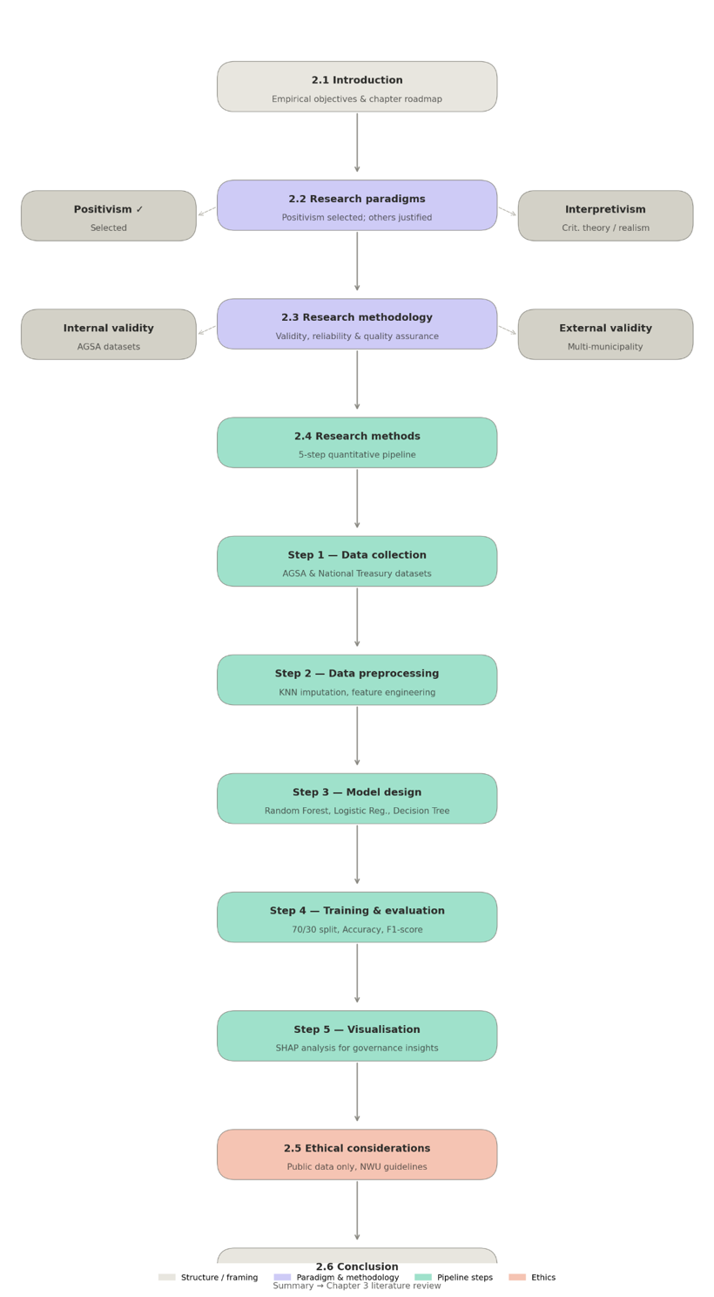
Figure 3 Chapter 2 Overview

2.2 Research Paradigms
A research paradigm can be described as an approach to research that can be used as guidance on how to interpret reality. Each paradigm is primarily defined by three fundamental questions: the nature of reality, the nature of knowledge and how it is acquired and the processes used to acquire knowledge. For computer science related studies there is 4 paradigms that can be applied: Positivism, Interpretivism, Critical Social Theory and Critical Realism.

- Positivism’s foundation relies on the idea that there only exists one objective reality apart from our human perception. Using this paradigm the researcher will measure, test and attempt to identify patterns using empirical data that fits their study’s context. The researcher also needs to maintain an objective and detached role throughout the entire process to ensure the methodology remains repeatable, systematic and value-neutral.
- Interpretivism holds that human meanings and interactions shape our reality which makes it socially constructed. This paradigm’s aim to evaluate and lived experiences through tools such as surveys where the researcher is able to collect qualitative data to understand the “how” and “why” of a phenomenon or event.
- Critical Social Theory is a paradigm that focuses on social change and emancipation by identifying and challenging oppressive social structures. With this paradigm the researcher does not have a detached role throughout the process, instead they will act as an agent of change in order to fulfil this paradigm’s main objective.
- Critical Realism offers a middle ground where reality gets divided into three domains. The first one is the real domain which refers to the underlying structures. The second is the actual domain which refers to the actual occurring events. Finally the third is the empirical domain which refers to what we are able to see and measure. This way this paradigm acknowledges that we live in an objective reality but it is also epistemologically cautious to recognise that sometimes our understanding of this world can be faulty or influenced by other humans and experiences.

The positivism paradigm was selected for this study because it has the most appropriate framework that aligns with the study’s main objectives and goals to measure, test and identify patterns in municipal data to design a model that can identify and predict water service delivery outcomes. Therefore, this makes this a quantitative task where there will be a formulation of hypotheses to be tested against structural and numerical data.

This study will also need publicly available datasets which is consistent with the standards of the positivism paradigm. The aim is to ensure the data collection and analysis processes are able to be reproduced and analysed by other researchers to maintain a high standard of rigour. This is the reason why alternative paradigms were deemed not suitable for this study. Interpretivism was not selected because it lacks the technical predictive modelling standard required to use municipal datasets to predict water service delivery outcomes. Critical Social Theory was not chosen because it leans more towards active social intervention while this study leans more towards operationalising a quantitative model.

While Critical Realism would also benefit the part of the study that mentions the local government as a complex social system, it was not chosen because it does not satisfy the main objective of this study which is to design a predictive model. This paradigm also does not align with the study’s quantitative empirical objectives because it leans more towards an abductive approach.

2.3 Research Methodology
This section will outline the quantitative methods that will be adopted in order to fulfil the study’s main objectives. These methods will be applied in a valid manner that aligns with the Positivism paradigm. These methods will be necessary to ensure that the Machine Learning model designed with the utilisation of municipal data is rigorous and adheres to the proper scientific standards of Artificial Intelligence and Machine Learning. The positivism paradigm will also establish the study’s trustworthiness to ensure validity and reliability.

This study will address two primary dimensions of validity which is Internal Validity and External Validity. These dimensions are included to be addressed by the study because they will outline the extent to which the research accurately measures the quantitative data it intends to utilise. Therefore ensuring that the findings truly represent and align with the study, and also answer the study’s research questions.

With internal validity it is guaranteed that any risk factors identified by the proposed model such as municipal audit outcomes and financial indicators, are the actual drivers of the performance behind the water service delivery in the local government. To maintain high internal validity, only structured and verified datasets from organisations such as the Auditor-General South Africa (AGSA) will be used. This way the risk of measurement errors and omitted variable bias is decreased to preserve the model’s accuracy during prediction.

External validity aligns with the approach of the positivism paradigm because its goal is to ensure the findings are generalisable across different municipal contexts in the South African local government. To ensure external validity the study will utilise datasets covering different metropolitan and local municipalities so the developed model’s predictive rules can be applied beyond specific training data.

For reliability, the consistency and stability of the research tools and findings is important. With this study’s context of Machine Learning modelling this will ensure that if the research were to be replicated using the same dataset and algorithms, the same results are produced. Therefore, this research’s approach will adhere to a systematic and replicable workflow that will include steps for data cleaning, feature selection and algorithm configuration. The usage of standard Machine Learning libraries and statistical software will also ensure the research output is not dependent on subjective researcher interpretation but mathematical computation that can be repeated.

Finally, for quality assurance the model’s performance will be analysed as the last stage of methodological rigour. As listed in chapter 1 of this study, to display the usefulness and effectiveness of the model’s predictions, performance metrics will be used. This includes Accuracy, Precision, Recall and F1-score to measure effectiveness and these criteria will also be used to verify the model’s ability to differentiate between “good” and “poor” water service delivery outcomes. Then to make it possible to test the model on untested datasets, the data splitting method will be used. This method divides data into training and testing sets to avoid overfitting and ensure the model is robust which is important rigour in data analysis.

For the context of this study the research design is structured as a predictive modelling pipeline. It ensures a systematic and replicable flow from raw municipal data to actionable insights that can be used for decision-making in governance.

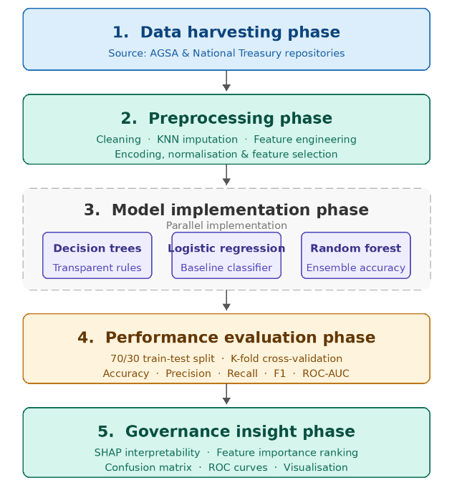
Figure 4 ML Pipeline Flowchart

This research design's structured and linear form supports positivism's demand for objectivity. The design guarantees that the researcher stays an impartial observer of the data by predetermining the variables, algorithms and evaluation measures. Because every stage of this design is replicable, the fundamental scientific condition of reliability might be accomplished by another researcher using the same National Treasury datasets and algorithmic parameters

2.4 Research Methods
This section will outline the specific tools and methods to be used to collect and analyse the data that will answer the study’s research questions. A quantitative research approach will also be adopted to ensure alignment with the positivism paradigm. This paradigm was justified as appropriate because it will allow the use numerical data to test hypotheses and identify the connection between the municipal data and water service delivery outcomes.

The application and selection of quantitative methods for this study is dictated by the study’s objective to design a predictive Machine Learning model. The quantitative methods that are suited for this task involve the measuring of relationships and predictions outcomes based on large and structured datasets. While qualitative methods may have the potential to provide contextual depth for the study, they lack the statistical generalisability and computational scalability required to design an appropriate robust, data-driven forecasting model.

To ensure the study is replicable and rigorous, the research process will consist of a step-by-step workflow:

2.4.1 Step 1: Data Collection
Secondary quantitative data will be collected from sources that are publicly available such as the National Treasury and Auditor-General South Africa (AGSA). These sources offer the public and South African municipalities verified audit results and financial indicators.

2.4.2 Step 2: Data Preprocessing
The raw collected data will undergo a cleaning process to ensure data anomalies such as duplicates and missing values are addressed. Depending on the amount and extent of the missing data, techniques such as the K-Nearest Neighbours (KNN) imputation or mean imputation will be applied. Then feature engineering will be used to derive the variables that captured long term performance trends instead of variables that captured single-year performances.

2.4.3 Step 3: Machine Learning Model Design
Three supervised machine learning algorithms will be put into practice and contrasted. They are the Random Forest, Logistic Regression and Decision Trees algorithm and were chosen due to their shown effectiveness in classification tasks and their potential for interpretability in governance contexts.

2.4.4 Step 4: Training and Evaluation
To verify the model's predictive accuracy on unseen data, the dataset will be divided into training (70%) and testing (30%) sets. The model’s performance will be assessed using a variety of metrics such as Accuracy, Precision, Recall and the F1-score. This is to make sure the model is fairly evaluated despite possible class imbalances in municipal performance.

2.4.5 Step 5: Visualisation and Interpretability
SHAP (SHapley Additive exPlanations) analysis will be used to convert technical data into useful governance insights. This technique determines whether particular risk factors such as poor financial management or deteriorating infrastructure have the most effects on the model's forecasts or not.

2.6 Conclusion
In conclusion, the systematic methodological framework required to handle the study's empirical objectives has been outlined in this chapter. The research ensures that evaluation of municipal water service delivery outcomes is objective, empirical and replicable through the application of a positivist paradigm. In order to guarantee the final Machine Learning (ML) model's rigour and trustworthiness, the chapter defined the technical standards for validity and reliability. A clear roadmap for the data-driven predictive pipeline, from the initial data collecting at the Auditor-General of South Africa (AGSA) to the comparative application of supervised learning algorithms, was also provided by the thorough description of research methodology and design.

Now that the study's technical design and methodological structure have been defined, the following chapter places this research in the context of a larger scholarly discussion. A thorough literature review is presented in Chapter 3, which examines the core concepts guiding the study, points out existing gaps in the area of municipal governance research and evaluates the state of machine learning applications in local government.

CHAPTER 3: LITERATURE REVIEW

3.1 Introduction
This study focuses on the data-driven prediction of local government water service delivery outcomes through machine learning in the South African local government context. Even though laws such as the Municipal Finance Management Act (MFMA) of 2003 were created to increase accountability and transparency in South Africa, many local and metropolitan governments still provide poor water quality services.

In order to comprehend the structural flaws in governance that conventional audit-based systems frequently miss, this chapter conducts a thorough assessment of the literature in order to address the theoretical goals of the study. This review creates a theoretical framework for applying predictive analytics to close the gap between financial compliance and the actual performance of community service by placing the research within the current scholarly debate.

A thorough synthesis of current and fundamental research on the relationship between technology and municipal government will also be presented in this chapter. The revolutionary potential of Machine Learning (ML), a subfield of Artificial Intelligence (AI) that allows computers to learn from large, complicated datasets without explicit programming to enhance the results of public service delivery will also be investigated. The chapter will also evaluate the systemic elements that lead to problems with service delivery in the South African setting, such as deteriorating infrastructure, financial mismanagement and institutional inefficiencies.

Therefore, this chapter's subsequent sections offer a logical outline of the main ideas that are essential to the study. First, using established use cases in resource management, agriculture, and health, it will evaluate machine learning (ML) as a predictive tool in public service delivery. Second, the literature on the state and difficulties of water service delivery in South African municipalities will be examined, with an emphasis on the differences in regional performance. The relationship between clean audit results and real service performance will then be critically evaluated with an emphasis on the documented inconsistencies between service excellence and financial compliance. Finally, the chapter will conclude by outlining the precise contextual and technical gaps in the literature that this study seeks to fill and also provide a justification for how the results will influence the model's design and variable selection.

3.2 Machine Learning as a Predictive Tool in Public Service Delivery
As a branch of artificial intelligence (AI), machine learning (ML) uses statistical models and algorithms that learn from data to find patterns and carry out tasks without explicit human guidance. In the modern era of "big data," machine learning (ML) has become a vital tool for shifting public governance from reactive to proactive, data-driven decision-making. In order to support the viability of employing such techniques to predict municipal water service delivery results in South Africa, this section examines documented implementations of machine learning across a variety of public sectors, including healthcare and resource management.

3.2.1 Sectoral Machine Learning Applications
Sub-Saharan Africa's healthcare industry offers substantial proof of machine learning's predictive capabilities in settings with limited resources. Using Electronic Medical Records (EMRs) from 25 Rwandan hospitals, (Sylvain et al., 2025:1) were able to predict unfavourable pregnancy outcomes with a high prediction accuracy of 90.6% using an improved Random Forest mode. Similarly, (Igbokwe & Nwamekwe, 2025:13) showed how supervised learning algorithms, including Decision Trees and Logistic Regression may efficiently stratify patient risk, enhancing clinical care and resource utilisation. These findings highlight that although machine learning models show great accuracy in controlled environments, inconsistent data quality and technological infrastructure flaws frequently undermine their trustworthiness in real-world scenarios.

ML has been effectively used to optimise municipal utilities and resources outside of the healthcare industry as well. In order to improve municipal solid waste management,(Taweesan et al., 2025:1) combined clustering methods with machine learning. Decision Tree models were able to determine effective collection coverage with up to 75% accuracy. In the context of water resources, (Hirko et al., 2026:14) developed a hybrid ML framework to optimise water allocation in Ethiopia under climate and population pressures. Their findings revealed that Random Forest models outperformed sequential algorithms like Long Short-Term Memory (LSTM) in capturing the non-linear interactions between human consumption patterns and supply constraints. This research underscores the importance of incorporating historical demand trends and demographic dynamics into predictive frameworks to ensure sustainable resource governance.

Despite these technological advancements, structural obstacles stand in the way of the shift to AI-driven public service delivery. (Ngcobo, 2025:75) emphasises that although AI has the potential to transform care pathways and diagnostics, its efficacy depends on fair access and the reduction of algorithmic bias. (Mofokeng et al., 2025:2) contend that a lack of political will, financial limitations, and a lack of digital expertise among municipal officials commonly impede digital transformation in the context of South African local government. These results imply that a prediction model must be both highly interpretable for non-technical decision-makers and technically accurate in order to be useful in South African water governance.

In conclusion, research shows that machine learning (ML) is a flexible technology that can predict outcomes with high accuracy in the resource management and healthcare industries. The selection of ensemble methods such as Random Forest in this study has a strong technical justification due to their superior performance in both Ethiopian water distribution research and Rwandan health studies. The suggested model for South African municipalities must be created with the unique institutional realities of local governance in mind, though, given the persistent issues with data quality and institutional capabilities noted in the research. The variable selection and algorithm setup throughout the research's later design stages will be guided by these discoveries.

3.3 Water Service Delivery Status and Challenges in South Africa
Section 27(1)(b) of the Constitution of the Republic of South Africa (1996) guarantees access to adequate and healthy water as an unalienable human right. For many local and metropolitan communities, providing dependable water services continues to be a major difficulty despite this constitutional obligation and the regulatory frameworks established by the Water Services Act 108 of 1997. This part looks at the state of service delivery today, emphasising the geographic differences in access as well as the structural governance and infrastructural flaws that cause ongoing water outages and discontent in the community.

Access to improved water sources increased from 85.1% in 2011 to 88.5% in 2022, according to national statistics, but these numbers conceal notable regional differences. According to (Ishola et al., 2025:84) Buffalo City and eThekwini have significant rates of water service interruptions, although urban municipalities like the City of Cape Town and Ekurhuleni retain high levels of water access with 99.8% and 99.3% respectively. Additionally, there is still a dual service experience in which 79% of urban dwellers are happy with the quality of the water, while only 64% of rural residents which many of whom still depend on rivers and wells. According to (Mamokhere, 2025:36), poor service delivery has increased violent protests nationwide for which in early 2024, 38% of riots were particularly linked to problems with water or electricity.

One of the main causes of these service delivery failures, according to the literature, is deteriorating infrastructure. (Seema et al., 2025:5) discovered that 80% of the reticulation network in the Modimolle-Mookgophong Local Municipality (MMLM) is made up of outdated asbestos pipes which causes frequent winter bursts and large water losses. The results of the Water Infrastructure Quality Index (WIQI) which indicate that even cities with ostensibly excellent infrastructure such as the City of Johannesburg, nonetheless have problems with persistent leaks and unauthorised connections. (Nodipha et al., 2025:1375) also point out that outside variables like load shedding, which interferes with the distribution and processing of water and cable and water pump theft and vandalism further impair municipal capacity to deliver a steady supply.
Beyond technical problems, the industry has significant challenges related to governance and financial mismanagement. (Mamokhere, 2025:31) contends that a lack of institutional capacity, political-administrative meddling and administrative inefficiency are the root causes of current problems. For instance, the Water Services Authority in MMLM barely runs at 70% of its potential because of a serious lack of certified process controllers and skilled employees. Even when finances are available, institutional inefficiencies and financial mismanagement frequently lead to the failure to maintain existing infrastructure which results in a cycle of reactive repairs rather than proactive maintenance (Ishola et al., 2025:91).

In conclusion, research suggests that the landscape of water service delivery is fragmented and marked by significant disparities across urban and rural municipal contexts. Ageing infrastructure, environmental stressors like load shedding and systemic governance flaws all delay the shift from financial compliance to real service excellence. These complex issues highlight the need for a predictive program that can identify towns at danger of failing before service disruptions spark public outcry. The main variables for the Machine Learning (ML) model suggested in this study would be these identified risk factors which range from the state of the infrastructure to a lack of technical expertise.

3.4 The Relationship Between Clean Audit Outcomes and Actual Service Delivery
A strict auditing structure that is intended to impose good financial governance, accountability and openness governs the local government in South Africa. A municipality's financial statements are free of material misstatements and the entity has complied with all applicable laws while accurately reporting against its predetermined performance objectives, according to a clean audit outcome which is a concept specific to the South African municipal context. This section examines the systemic reasons why audit excellence does not always convert into service excellence and critically assesses the presumed causal relationship between these financial compliance indicators and the actual provision of services to communities.

3.4.1 The Compliance-Performance Gap
Whether financial compliance accurately predicts operational performance is a major point of contention in municipal government studies. Strong financial management is the foundation around which efficient service delivery revolves, according to legislative frameworks like the Municipal Finance Management Act 56 of 2003 (MFMA). But according to (Sambo, 2019:5), an unqualified audit opinion does not necessarily mean that public services are delivered effectively or efficiently. The Western Cape which has historically had the highest percentage of clean audits (70%), serves as an example of this. Despite this, service delivery protests are nevertheless common and are frequently linked to the perceived shortage of housing and infrastructure. This implies that audit results are frequently after the fact and could miss the underlying reasons for poor service delivery, such deteriorating infrastructure or incompetent leadership.

Therefore, the literature identifies a clear disconnect whereby communities may attain financial compliance by emphasising administrative tick-box activities above meaningful service delivery. Through thorough empirical investigation, (Craig, 2017:3) discovered that there is, at most, a weak correlation between clean audits and service delivery. The results indicate that a municipality's ability to provide services is not so much affected by its audit status as it is by its operational context which includes regional wealth levels, population density and infrastructure availability. Additionally, the existing system may lead to perverse incentives. For instance, municipal departments may set lower performance targets, also known as "stretch targets, in order to avoid bad audit findings, so they put a clean audit ahead of ambitious developmental goals.

An elaborate view of this relationship is presented by the Midvaal Local Municipality case. According to (Khasodi et al., 2023:338), Midvaal's consistent clean audits are a trustworthy sign of efficient service delivery since the municipality has successfully combined efficient management procedures with effective internal controls. This suggests that even while the audit system is frequently condemned for being one-size-fits-all, it can assess the calibre of services provided if administrative effectiveness is combined with a sincere dedication to citizen-centric performance.

However, it also noted that a general regressive trend in which fewer towns are obtaining clean audits due to persistent problems such irregular spending and non-compliance with supply chain management standards (S Mnguni, 2022:157). This financial crisis puts local government in a precarious situation and further separates the Auditor-General's reports from the lived reality of communities.

In conclusion, research indicates a substantial difference between operational success and financial compliance in South African municipalities. Although certain case studies, such as Midvaal, show that successful audits can be correlated with clean audits, more general national data indicates that financial compliance is a limited stand-in for superior service delivery. The findings suggests that institutional capability and socioeconomic factors have a larger role in service delivery than just following auditing laws. These findings support the technical justification for the suggested Machine Learning (ML) model, which has to include a larger range of indicators beyond conventional audit data in order to precisely pinpoint the trends and risk factors that result in subpar water service delivery outcomes.

3.5 How will the literature guide my study?
Critical observations from the systematic review of the literature form the basis of this study. The review has determined technological, contextual and theoretical factors that directly influence the study's design and variable selection by analysing the relationship between machine learning (ML), municipal governance, and water service delivery.

3.5.1 Guiding the Technical Design and Algorithm Selection
A technical justification for the use of particular machine learning algorithms has been provided by the literature review. The adoption of Random Forest as the main model in this investigation is justified by its proven effectiveness in resource-constrained healthcare settings in Rwanda (Sylvain et al., 2025:8) and water allocation tasks in Ethiopia (Hirko et al., 2026:18). Additionally, the literature's frequent accuracy-interpretability trade-off (Igbokwe & Nwamekwe, 2025:14) supports the need for SHapley Additive exPlanations (SHAP). This guarantees that the model's outputs deliver practical "risk factor" insights that city officials can comprehend and rely on, going beyond binary fail/success forecasts (Abujaber et al., 2025:3; Hirko et al., 2026:15)

3.6 Conclusion
In conclusion, this chapter has provided thorough synthesis of the academic discourse that supports the data driven prediction of the local government water service delivery outcomes through Machine Learning. Versatile applications of Machine Learning, which is a branch of Artificial Intelligence that focuses on learning and identifying patterns in large datasets, were evaluated and it was determined that algorithmic methods such as Random Forest achieve a consistent high predictive accuracy in public health and resource management sectors (Hirko et al., 2026:14; Ngcobo et al., 2025:10).

The analysis of the South African local government from the municipal context revealed that there exists persistent conundrums such as inadequate infrastructure and a technical skills shortage which are hidden by the current traditional methods used for financial reporting (Mamokhere, 2025:31). Most importantly, the literature also suggests that there is a significant gap regarding compliance performance in the local government and that the Auditor-General of South Africa’s are not a true indicator of the actual water service delivery audit results (Sambo, 2019:5). Collectively, these findings suggest that there is solid rigorous and technical justification for designing a predictive model that uses operational and financial indicators from the local government.

The study will now move on to the subsequent chapter, The Empirical Study. The aim of this chapter is to provide details on how the research design will be put into practice. This also includes the description of the processes of data collection, application of the K-Nearest-Neighbours method for data cleansing and how the algorithms proposed in this study will be compared and validated against each other to identify the most optimal one for the predictive model.

Chapter 4: Empirical Study

4.1 Introduction
The focus and primary objective of this study is to predict water service delivery outcomes in the South African local government using data driven methods and machine learning. The local government is the centre of what most communities depend on in their everyday lives. This includes basic public services such as electricity, sanitation and clean water (Craig, 2017:11; Nodipha et al., 2025:1371). There has been a decline and hardly ever an increase in water service delivery outcomes for nearly decades, despite the existence of systems that were developed to enforce accountability and ensure there is a decrease in persistence water interruptions.

These traditional audit assessment systems have played an important role in ensuring that communities members and their local municipalities have a transparent relationship between them but they fail to capture the underlying factors that contribute to the overall negative water service delivery in most communities (Ishola et al., 2025:84). Communities can see these systems collapse in real time but they cannot see the operational risk factors that are behind every poor service delivery they experience. Therefore, this study aims to address this gap by employing quantitative modelling and data driven methods that identify and expose the structural risk factors of water supply instability before service failures occur.

This chapter discusses the empirical objectives such as the 4.3.1 Data Collection and preprocessing of public municipal datasets, designing and comparing Machine Learning algorithms 4.5.1 Performance Metrics, and identifying and evaluating the most impactful factors that contribute to poor water service delivery outcomes in the local government using 4.5.3 SHAP Interpretability. Every discussion in the chapter will be grounded in the Positivist research paradigm using quantitative methods. Therefore this chapter will move this study from a conceptual and methodological development to a more technical development. For the purpose of this chapter, several core terms are freshly defined to maintain complete scientific clarity and technical rigour:

- Machine Learning: Branch of Artificial Intelligence that uses statistical models and algorithms as methods to identify and predict patterns in data. It can execute classification and predictive tasks and is independent of hard coded programming.
- K-Nearest Neighbours: Statistical preprocessing distance method that can be used to estimate and impute missing values in a dataset. This is achieved through assessment of the k most similar municipal observations in a multi-dimensional feature space.
- SHapley Additive exPlanations: Framework that can be used to convert complicated mathematical outputs into interpretable and transparent governance insight. It achieves this by calculating the marginal contribution of individual features to a model’s prediction.

4.2 Experimentation Design
The basis of this empirical study revolves around a quantitative experimentation design where the conceptual framework of the study will be translated into a repeatable predictive modelling pipeline. The set up of this experimentation design involves objectively measuring, evaluating and comparing the performance of three machine learning algorithms. The 4.2.1 Prediction Model Architecture of the experimentation design, the definition and 4.2.2 Target Variable Operationalisation, the 4.2.3 Input Feature Matrix and Selection Reasoning and the 4.2.4 Algorithmic Implementations and Hyperparameter Tuning are covered in this section.

4.2.1 Prediction Model Architecture
The experimental design is a five-stage predictive pipeline that mirrors the Knowledge Discovery in Databases process model, where data mining is viewed as an important step in extracting valuable information from unprocessed data. The stages in the pipeline are namely:

- Data Harvesting and Ingestion: Downloading the municipal dataset from government sources and websites such as the Auditor General South Africa (AGSA) and Municipal Money.
- Preprocessing and Data Refinement: Using K-Nearest Neighbour imputation to handle missing values, standardising range variations using feature scaling and encoding categorical properties.
- Model Configuration and Training: A stratified 70% for training and 30% for testing dataset division for this part of the model architecture. The three models that are going to be used along with the training are Decision Trees, Logistic Regression and Random Forest.
- Evaluating Model Performance: The resulting models will be tested against several mathematical metrics such as Accuracy, Precision, Recall, F-1 Score and ROC-AUC. This is to ensure that algorithmic capabilities are compared on unseen data.
- Interpretability Analysis (SHAP): Feature level contribution scores will be extracted using cooperative game-theoretic explanations then the “black box” outputs will be transformed into actionable risk factors that are transparent for the local government.

4.2.2 Target Variable Operationalisation
The target variable is developed as a discrete indicator that represents the South African local government performance in water service delivery for each municipality. This formulates the models prediction as a binary classification task.

$$y∈\left\{0,1\right\}$$
Where:
- y = 1 (Poor performance): This variable represents a municipality that experiences constant and significant water service interruptions, inadequate access to tap water in households and the overall community or high risks in physical and operational water quality.
- y = 0 (Acceptable Performance): This variable represents a municipality that has its baseline water service delivery needs met. This can be adequate access to tap water, less frequent to no water service interruptions, low risk in physical or operational water quality, stable water quantity and consistent household satisfaction.

For the execution of this target variable, a composite index integrates key performance indicators (KPIs) from a selected regulatory performance system is required. In particular, the following is used to determine what defines poor water service delivery:

- Water Quantity Access: The percentage of households who have direct access to piped water in their homes.
- Supply Continuity: The frequency and duration of water service interruptions that have resulted in local protests and severe community dissatisfaction.
- Blue drop risk rating: This is the regulatory water quality compliance score calculated by the Department of Water and Sanitation.

4.2.3 Input Feature Matrix and Selection Reasoning
The input feature matrix will combine traditional retrospective audit indicators with operational, infrastructural and socioeconomic indicators to close the documented compliance gap. This approach is motivated by the empirical findings that suggest that water service delivery outcomes cannot be represented by municipal financial compliance alone.

The feature matrix is divided into four categories:

- Financial Audit and Compliance Indicators: This can include audit outcomes datasets published annually by AGSA.
- Institutional Capacity and Governance Variables: Measures of municipal administrative capacity, including the number of open technical positions, the availability of skilled engineering workers and the presence of certified water process controllers.
- Infrastructural and Technical Risk Factors: Empirical variables that represent asset maintenance budgets, exposure to external operational stressors such as electricity load shedding and physical infrastructure issues such as outdated piping.
- Socioeconomic and Contextual Control Variables: To separate the impact of geographic and resource differences on water delivery capabilities, regional wealth levels, family income averages, population density and municipal classification types will be considered.

4.2.4 Algorithmic Implementations and Hyperparameter Tuning
For this study, three supervised machine learning algorithms are implemented and compared:

- Decision Trees: This algorithm was selected because it has a high degree of transparency and rule-based interpretability. By using conditional splits to divide the municipal feature space, this algorithm can generate a readable hierarchical map that can be easily understood by non-technical governance workers.
- Logistic Regression: This classification algorithm is mathematically rigorous and is used as a baseline for binary outcomes. It predicts the probability of a water service delivery failure using a logistic function. This function then generates interpretable coefficient outputs that measure the strength and direction of each predictor’s relationship with the outcome variable.
- Random Forest: This was selected because it is an ensemble classification algorithm that consists of several decision trees. It also has exceptional accuracy, resistance to overfitting and the ability to capture complicated , non-linear connections between diverse municipal datasets.

Hyperparameter tuning is carried out using a grid search to explore predefined algorithmic ranges following the methodology by (Sylvain et al., 2025). For the Decision Tree, Gini impurity or entropy criteria is used to optimise splits then maximum depth constraints are used to prevent overfitting. For Logistic Regression L1 (Ridge) or L2 (LASSO) regularisation is applied to prevent multi-collinearity in highly correlated financial indicators. With Random Forest the number of trees, maximum tree depth and the minimum tree samples required at a leaf node get systematically tuned to identify the optimal balance between model complexity and generalisation capability.

4.3 Data Preparation and Refinement
This section discusses 4.3.1 Data Collection which covers how the municipality data used for this study’s model was retrieved, prepared and refined. Data preparation is a necessary step in creating a machine learning prediction model because it ensures the data is organised and processed in a manner that makes it easy to present using Business Intelligence (BI) methods and data visualisation applications. Real world data is often not perfect and might have missing values that make it inconsistent, making it difficult to make use of it to exhibit patterns or trends that may be useful as information to relevant users. Therefore this step ensures the data is processed to exhibit any existing patterns and trends that may be relevant for decision making.

4.3.1 Data Collection
The process of creating a model includes the collection of data as the first step. Initially data was collected from a publicly available website called Audit-General South Africa where municipal data is made available to the public annually. After the data was downloaded it was discovered that it is mostly available only in a pdf format which would have resulted in a longer and more difficult preprocessing phase therefore an alternative was considered.

As an alternative, the Municipal Money website (municipalmoney.org.za) was used to collect the data. This website was selected because it allows users to download municipal data in different formats and it is dataset similar to the data made available on Audit-General South Africa. The CSV format was then selected when downloading the data because this format makes it easier to use the data for preprocessing.

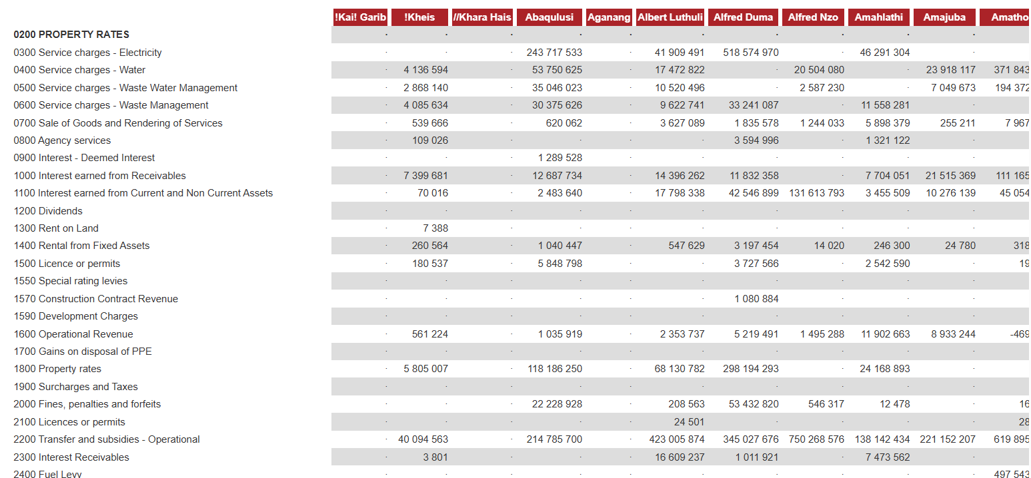
Figure 5 Raw municipal data as presented on Municipal Money website

4.3.2 Data Cleaning
Data cleaning is a step that exists to ensure data quality is enhanced and it was completed using Jupyter Notebook. In the case of this study it may be necessary due to due to situations such as administrative instability and uneven municipal record-keeping systems. Clean data ensures the machine learning process is efficient and accurate for the prediction model.

4.3.3 Filtering Out Non-Audited Records
The first cleaning task was completed immediately after loading the municipal data into Jupyter Notebook for the model. The Municipal Money datasets contain multiple types of financial figures, the data was filtered to retain only records where the “amount_type.code” was equal to “AUDA” which means Audited Actual and where “period_length.length” was equal to “year”. This omitted the inclusion of any unaudited or partial year figures that had the potential to disturb the model’s learning.

4.3.4 Removing Irrelevant Columns
The raw dataset included metadata columns that would have carried little to no value to the model training and prediction task. This included columns such as “amount_type.label”, ”amount_type.code” ,”period_length.length” and “item.composition”. Therefore only columns that are relevant to this study and the model’s training were retained. This removal of irrelevant columns reduces the dimensionality of each dataset before any merging is done.

4.3.5 Removing Item Level Duplication
In the raw downloaded dataset, each municipality appeared more than once a year with one row for each financial item. This was caused by the data being recorded at line-item level. This could have resulted in severe duplication of the dataset after merging. To avoid any duplication the data was aggregated to a municipality year level so each municipality appeared exactly once in the merged dataset.

4.3.6 Handling Missing Values Using KNN Imputation
A distance-based K-Nearest Neighbours (KNN) Imputation technique was used because the dataset had a lot of missing values. The Euclidean distance formula which calculates the straight-line distance between two observations across all completed features, was used to calculate similarity:
$$\text{Distance}\left(x,y\right)=\sqrt{\sum_{i=1}^{n}{{\left(x_{i}-y_{i}\right)}^{2}}}$$
This is how the KNN imputation was set up:
- Imputation Boundary Formulation: The quality gates established by (Sylvain et al., 2025:3) suggest that variables with more than 20% missing records were completely eliminated from the analysis to avoid the introduction of artificial noise.
- Neighbour Selection: To establish a suitable balance between local detail and global generalisation, the ideal number of nearest neighbours was set at k = 5 to match the parameters verified in the hydrological modelling of (Hirko et al., 2026:18).
- Imputation Execution: The mean of the five closest municipal neighbours was used to substitute missing values for numerical variables.

4.3.7 Removing Data Leakage
An important data cleaning had to be made after the initial model training indicated that all algorithms have a high performance score. Decision Trees had a ROC-AUC score of 0.99 and Random Forest had a score of 1.00. After a thorough evaluation, three expenditure columns were identified to have been included as input features during model training. This was incorrect because it meant the model was being given an answer along with the question for its training. These three columns were “irregular expenditure”, “unauthorised expenditure” and “fruitless and wasteful expenditure”, and they were removed from the feature set before the model was retrained, resulting in 16 predictor variables. This task was essential to ensure that the model performed in a manner that reflected legitimate predictive ability and not a definitional shortcut.

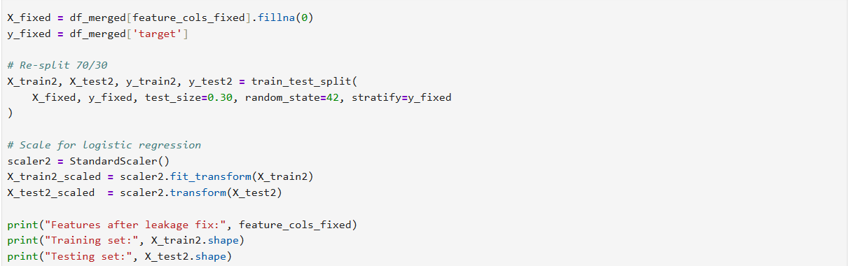
Figure 6 Code for removing data leakage

4.3.8 Filling Residual Missing Values in Engineered Features
After feature engineering was completed the yearly irregular expenditure variable included missing values for the first recorded year of each municipality. This was a result of not having a prior year to include in the calculation of change, therefore these values were filled with zeros before model training.

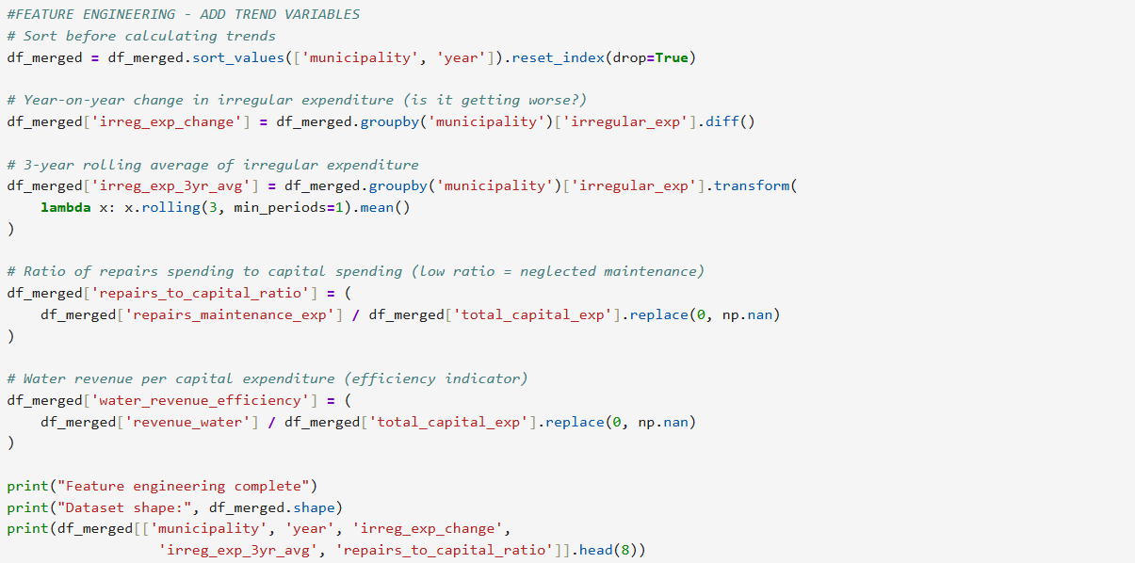
Figure 7 Code for feature engineering

4.4 Experimentation Conducted (ML Implementation)
This section will discuss how the machine learning training and evaluation of the model was conducted for this study. After cleaning and analysing, the dataset was well prepared for the modelling phase. This phase includes the implementation of algorithmic training using independent variables obtained from the clean municipal dataset to predict a binary classification water service delivery outcome indicator that represents South African municipalities.

4.4.1 Data Partitioning
Data partitioning is step in the modelling phase where data is divided into parts before it is used to train the model. One part is used for the model to learn from and the other part is retained for when the model has to be tested on data it has never seen before.

For this study the pre-processed data had 3 375 records and it was divided into a 70% and 30% split before the model training step. Therefore the model was trained on 2 362 records and tested on 1 013 records. The partitioning process was done using the “train_test_split” function from the scikit-learn library in the Python programming language. This function has a fixed random state of 42 to ensure the data partitioning is reproducible which is consistent with the standards of the Positivist paradigm.

To ensure the proportion of good and poor water service delivery outcomes is retained during the training and testing steps, stratified sampling was applied when the data was being partitioned and this was achieved by setting the stratify parameter used in the model to be equal to the target variable. Stratification also ensures random sampling does not produce unjust subsets since there was already moderate class imbalances that existed in the dataset. This was going to negatively impact the reliability of the model’s evaluation metrics and possibly affect the original class distribution of the poor and good outcomes.

An additional pre-processing step was applied to the partitioned data for the Logistic Regression algorithm to accommodate its sensitivity against the size of the input features. A function called StandardScaler also from the scikit-learn library was used to standardise the training and testing datasets by altering each feature to have a statistical mean of 0 and a standard deviation of 1. The scaler was fitted only on the training dataset then applied to the testing dataset afterwards to prevent data leakage between the training and evaluation phase of the model. The Decision Tree and Random Forest algorithms did not require this step because they react in a stable manner to scaling.

4.4.2 Algorithm Training
Algorithm training is a process where a selected algorithm attempts to understand the training dataset by learning its patterns, characteristics and relationships between the input variables and the target variable outcome. For this study the selected algorithms were trained on municipal datasets to learn the combinations of input variables that are frequently associated with poor water service delivery outcomes.
The selected supervised machine learning algorithms for this study and model are Decision Tree, Logistic Regression and Random Forest. The training was completed on already partitioned dataset and implemented in the Jupyter Notebook coding environment. The Decision Tree algorithm was trained on training dataset with no scaling. It produces a set of interpretable if-then rules that may be helpful when the information the model outputs has to be interpreted by a non-technical person.

The Random Forest algorithm was also trained on dataset with no scaling. It uses an ensemble technique to build a 100 Decision Trees where each one is trained on a percentage of the training dataset that was selected randomly. Its final prediction gets determined through a majority vote across all trees which may result in a more accurate prediction compared with a single decision tree.

The Logistic Regression was trained on a scaled dataset and it models the probability that a municipality-year record belongs to the poor class or not using a linear combination of input features passed through a logistic function.

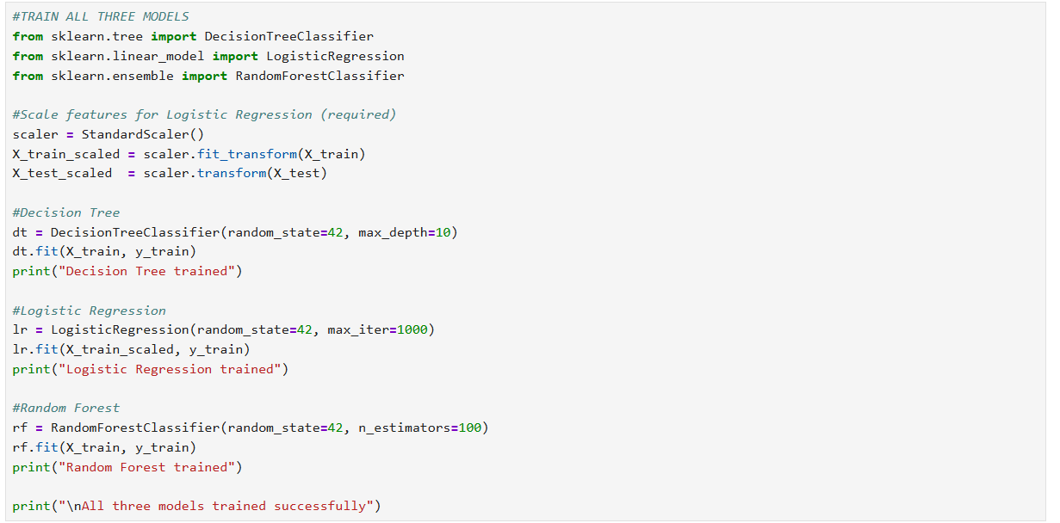
Figure 8 Code for training the algorithms

4.4.3 Hyperparameter Tuning
Hyperparameter tuning is a process where by the researcher selects hyperparameter values that have an influence on a machine learning algorithm’s behaviour during training. For this study the Decision Tree was set to a maximum depth of 10, Random Forest was set to a depth of 100 while Logistic Regression was set to 1000.

4.5 Analysis of Results and Trustworthiness
This section discusses the findings on comparing the selected machine learning algorithms on the merged municipal dataset that had 3 375 records across 292 South African municipalities, also spanning across 14 financial years. These findings are discussed in terms of how the three selected and trained machine learning models performed with their predictions, the trustworthiness of the results and what was derived from the SHAP interpretability analysis applied to the model with the best performance.

4.5.1 Performance Metrics
The machine learning models were evaluated using five performance metrics, namely accuracy, precision, recall, F1-Score and ROC-AUC.

Table 2 Algorithm Performance Metrics
Model | Accuracy | Precision | Recall | F1-Score | ROC-AUC
Decision Tree | 0.881 | 0.889 | 0.927 | 0.913 | 0.906
Logistic Regression | 0.760 | 0.773 | 0.912 | 0.837 | 0.749
Random Forest | 0.917 | 0.918 | 0.963 | 0.940 | 0.967

In all five performance metrics, Random Forest demonstrated to be the best one. Achieving an accuracy of 91,7% means it correctly classified 917 out of 1000 municipality-year records. With precision it means whenever the model predicted a poor water service delivery outcome it was correct 91.8% of the time. Its recall value suggests that the model’s success rate on identifying actual poor water service delivery outcomes was 96,3% with the testing dataset.

This is an important quality for the model because it covers this study’s main objective that includes the identification of areas with a lot of water service delivery outcomes. This is because failure to identify these areas may result in devastating consequences for the communities affected. The F1-Score value shows that there is a strong balance between the precision and recall value then the ROC-AUC value indicates reliability, suggesting that the model is able to distinguish between good and poor water service delivery outcomes. Therefore Random Forest had the highest reliability.

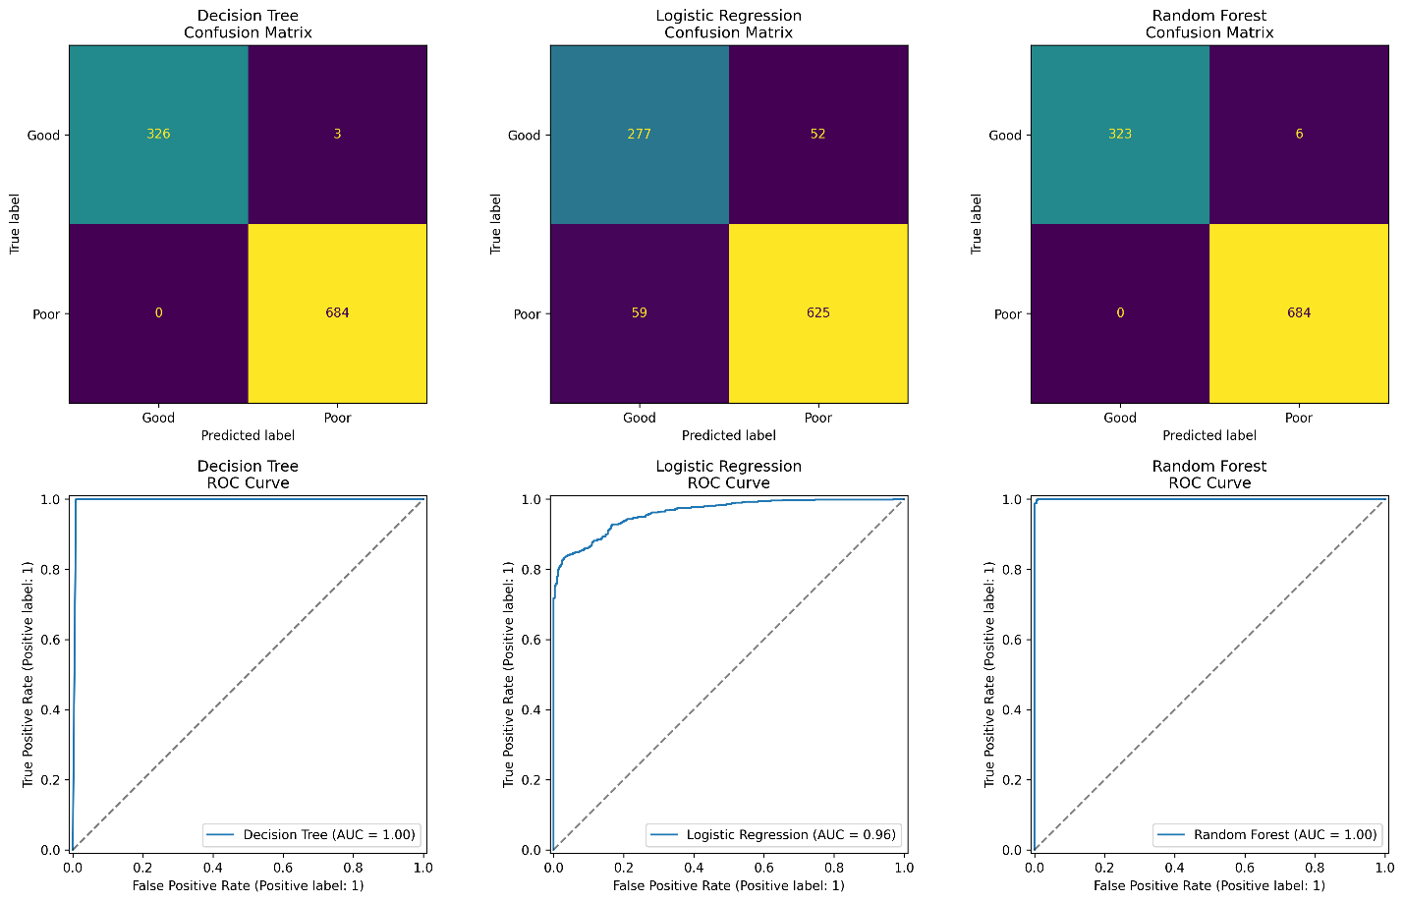
Figure 9 Model Evaluation

4.5.2 Trustworthiness
The trustworthiness of this study was maintained through internal validity, external validity and reliability as discussed in chapter 2. The internal validity was maintained through conducting a data leakage during the model training to ensure the model’s final results are valid and that its predictive performance is legitimate and a true reflection of patterns that were identified in the dataset.

The dataset used for the model training and testing spread across 9 South African provinces, 292 municipalities in 14 financial years, which supports the study’s external validity. Then reliability was supported by the usage of a fixed random state of 42 to ensure this study and the resulting model are reproducible and that any researcher applying the same code on the same dataset is able to get the same results.

4.5.3 SHAP Interpretability
After Random Forest was identified as the best performing model, SHAP was applied to the model to translate its predictions into actionable information that can be used in governance and to understand which variables impacted the model’s prediction the most. To achieve this each variable gets assigned a score that shows how much it contributed to a prediction then this is used to provide information on the reason the model classified that municipality as being at risk of poor water service delivery.

The SHAP results indicate that a municipality’s identity is the strongest predictor and this suggests that some municipalities may be at risk of poor water service delivery regardless of the financial year. This shows that institutional capacity and the context of the local government might be playing a significant role in water service delivery outcomes (Craig, 2017:89; Mamokhere, 2025:38). Irregular expenditure was the second important variable because it suggests that a consistent mismanagement of finances may be a stronger indicator compared to one bad financial year. Then the financial year variable is the third most important because it suggests that overall water service delivery has been declining over the studied period.

Therefore, SHAP analysis indicates that poor water service delivery outcomes may be associated strongly with how the local government institution performs and its mismanagement of finances overtime.

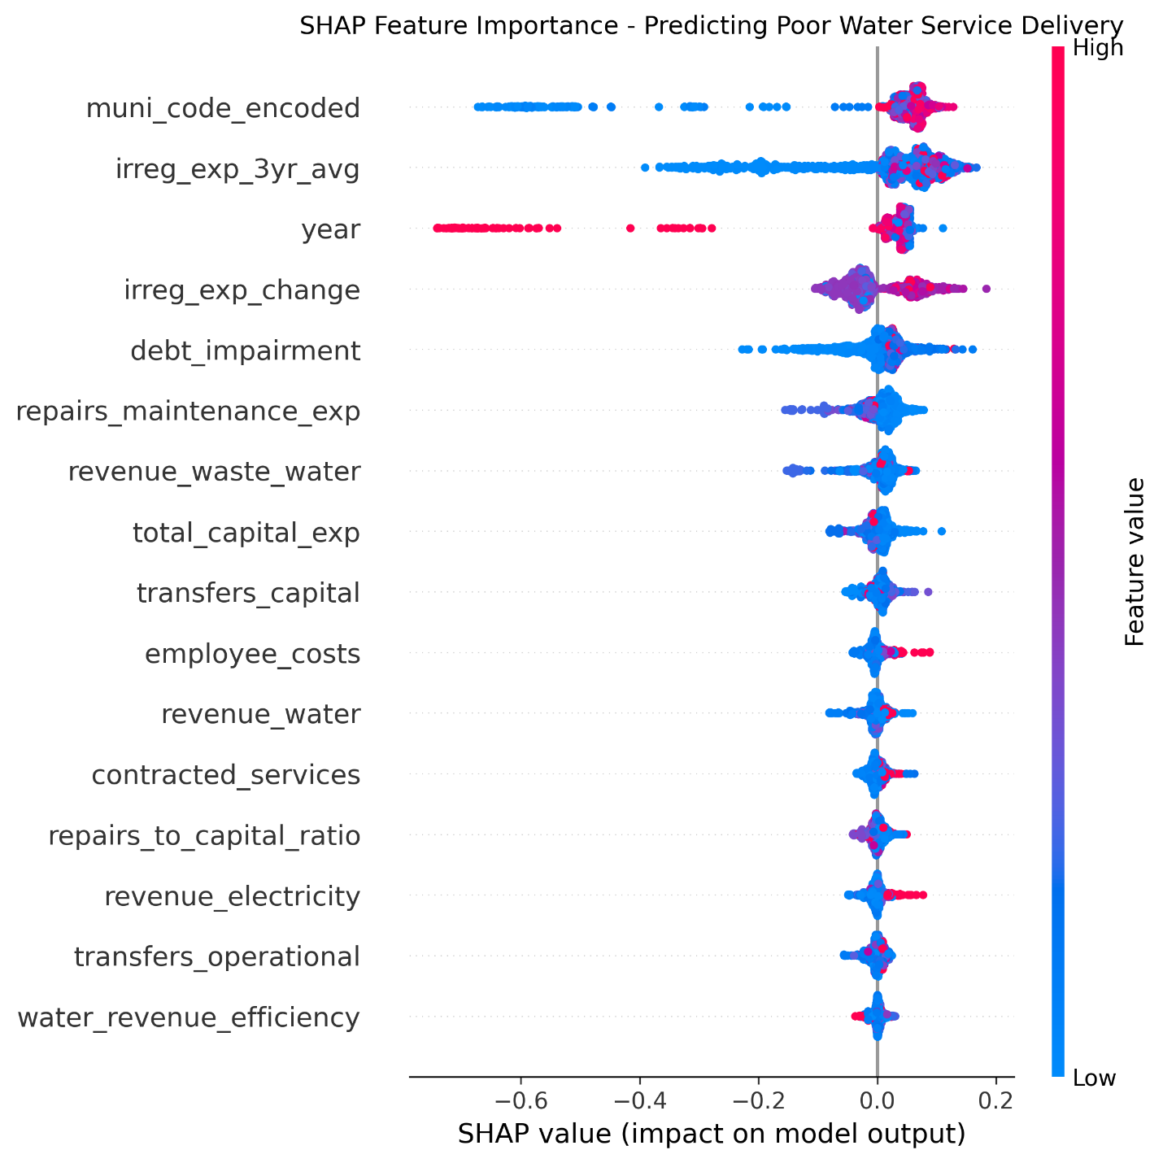
Figure 10 SHAP summary

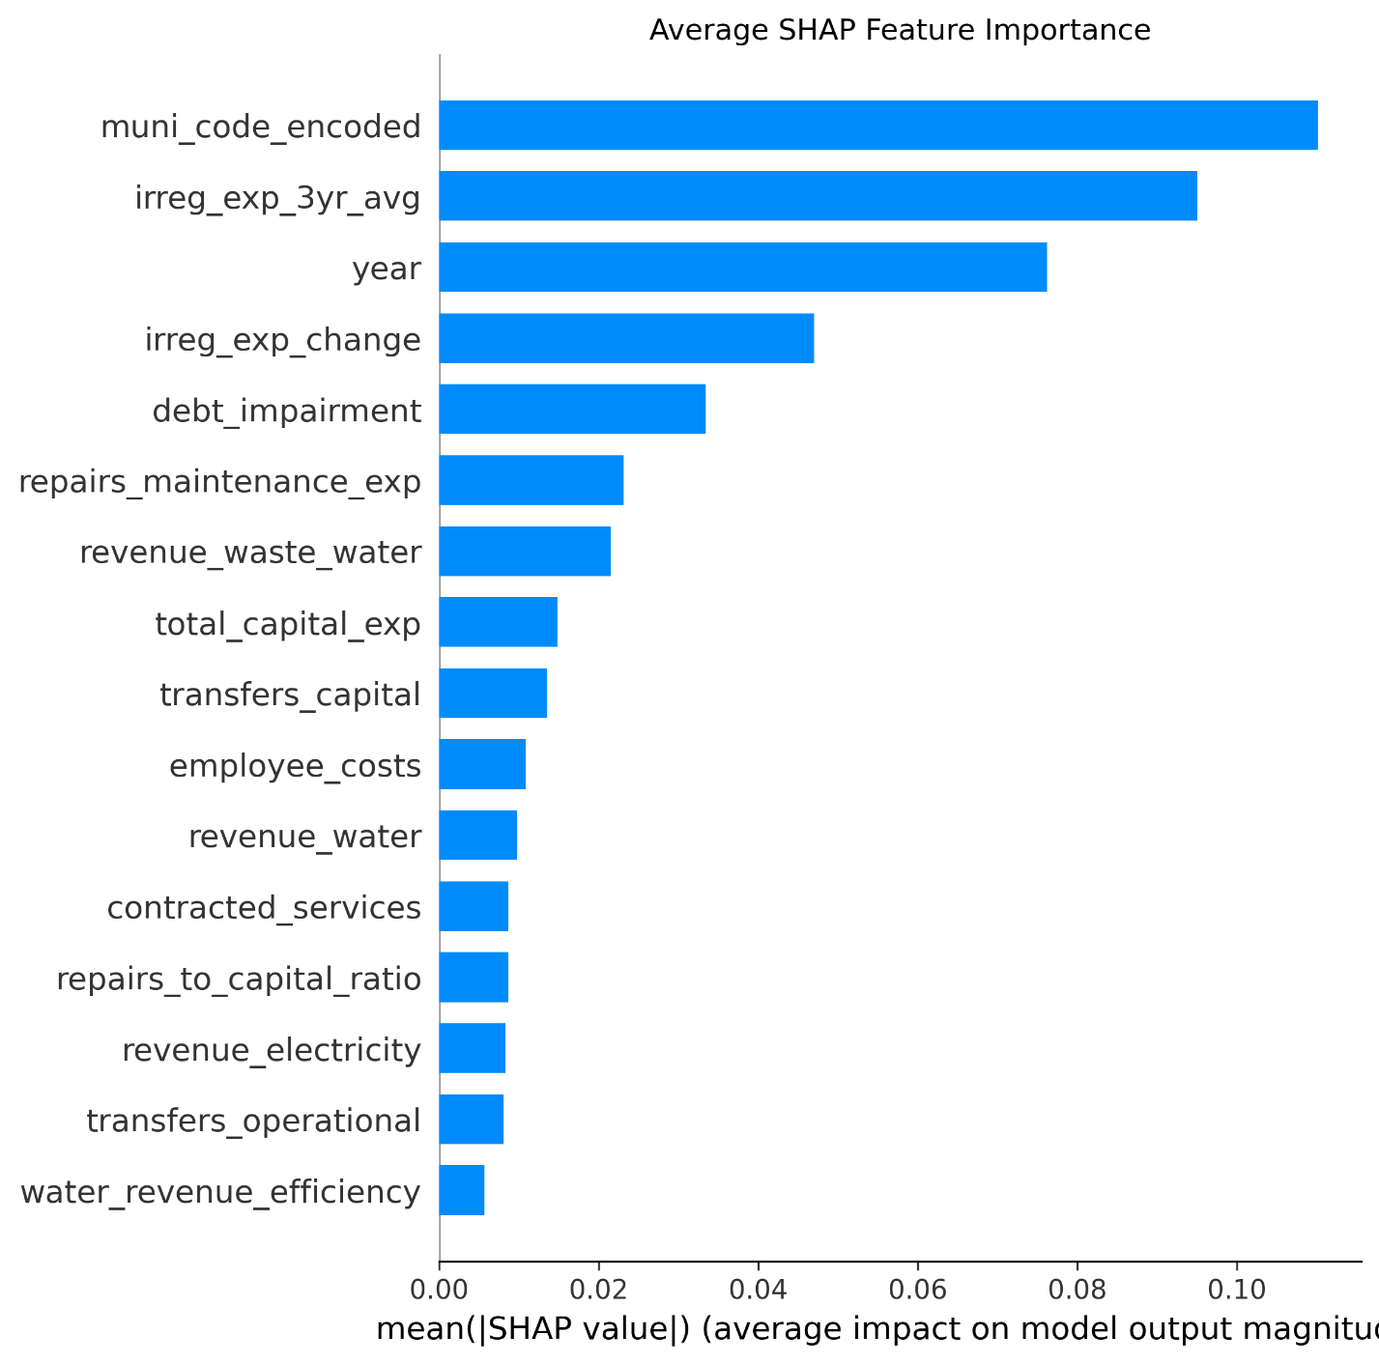
Figure 11 SHAP bar graph

4.6 Findings
Three machine learning algorithms were evaluated to assess whether they can be used to predict water service delivery outcomes in the local government using publicly available municipal data. The performance of the models, the risk factors identified through interpretability analysis and the implications of the results will be discussed in this section to present the findings.

4.6.1 Model Performance
As discussed in section 4.5.1 Performance Metrics, out of the three trained models Random Forest outperformed both Decision Trees and Logistic Regression in all performance metrics. These results confirm its reliability and that machine learning has the potential to be used as a predictive tool for identifying municipalities that are at risk of poor water service delivery outcomes.

4.6.2 Risk Factors
As discussed in section 4.5.3 SHAP Interpretability, SHAP interpretability analysis suggests that some municipalities may be carrying a constant risk of poor water service delivery that is not even captured correctly by any financial indicator. Proving that the institutions capacity and the context of the municipality in the local government can impact water service delivery outcome performances.

Mismanagement of finances consecutively over several years might also be a strong indicator for a municipality at risk of poor service delivery compared to any irregular expenditure recorded in one cycle. It is also evident that water service delivery outcomes have been declining over the studied period of time and there is also a decline in the amount of municipalities that have been displaying clean data audits in the same period of time (S Mnguni, 2022:153).

Debt impairment and yearly fluctuations in irregular expenditure also contributed to the models predictions and this suggested that neglected municipalities in terms of infrastructure maintenance and revenue collection are also at risk with poor water service delivery outcomes. Therefore, neglected maintenance of the infrastructure along with mismanagement of finances may be contributing to the poor water service delivery outcomes in South Africa (Ishola et al., 2025:77; Nodipha et al., 2025:1374; Seema et al., 2025:7).

4.7 Conclusion
This study proved that machine learning algorithms can be used to predict water service delivery outcomes with good accuracy using publicly available municipal datasets. Random Forest was identified as the best performing algorithm and model after achieving an accuracy of 91.7% and ROC-AUC of 0.967 during model testing.

Therefore, this suggests that data prediction can be a valuable addition to the South African local government’s current audit-based systems. This might allow for the early detection of municipalities at risk of poor water service delivery to minimise or prevent the risks before they turn into real consequences for the communities affected. This study also identified that consistent underperformance of local government institutions and mismanagement of finances over the several years has an impact on the decline in water service delivery outcomes. This also implies that paying attention to a municipality’s historical data may be a better alternative than yearly assessments alone when it comes to determining whether a municipality is at risk or not.

In conclusion, this study has the potential to contribute to the already existing research on machine learning and applying it in the local government for monitoring and decision-making. It may also serve as a foundation for data driven approaches to the local government service delivery in the future.

CHAPTER 5: CONCLUSION

5.1 Introduction
This chapter discusses the conclusion of the research study with title Data-Driven Prediction of Local Government Water Service Delivery Outcomes through Machine Learning. The South African local government is defined as the primary sphere for ensuring the constitutional law specified in Section 27(1)(b) of the Constitution of the Republic of South Africa is obliged to. This law states that Water Service Authorities are responsible for providing safe and good quality water supply to communities on a continuous basis (Ishola et al., 2025:76; Seema et al., 2025:1). To promote transparency and accountability in governance the local government relies on reporting frameworks (S Mnguni, 2022:148).

Even with the existence of the reporting frameworks, the local government’s service delivery in water supply is declining. Many communities are marked by persistent water supply interruptions, old infrastructure, high amounts in non-revenue water losses and an increase in public protesting against municipalities (Mamokhere, 2025:31). The main challenge that contributes to the poor water service delivery outcomes in governance was identified to being the results from the compliance gap that exists in governance administration. This suggests that reporting frameworks such as Auditor-General South Africa (AGSA) publish audit results that do not necessarily reflect the actual water service delivery being received by many communities (Khasodi et al., 2023:338). Therefore, municipalities may achieve consecutive positive results on audit reports while the communities they are responsible for suffer in the background.

This study addressed this gap by implementing, comparing and evaluating three supervised machine learning algorithms through modelling. It also evaluated whether the model has the ability to accurately forecast water service delivery outcomes using municipal datasets where financial audit indicators were integrated with operational risk metrics. The dataset repairs and maintenance expenditure, water service revenue metrics and capital investment. However, public resources do not provide direct and structured operational risk data such as water interruption records. This meant that the data could be included during the implementation of the model but such data is recommended as a direction for future studies.

The remainder of this chapter discusses the overview of the research journey and the achievement of objectives where the research questions and objectives will be covered in Section 5.2. Followed by the discussion of the study’s academic, governance and methodological contributions in Section 5.3, with the limitations identified and recommendations for future studies in Section 5.4. Then Section 5.5 discusses the study’s trustworthiness with Section 5.6 and 5.7 concluding the study’s remarks.

5.2 Overview of Research Journey and Achievement of Objectives
This section discusses how the study followed the Positivism approach using quantitative methods and also evaluates whether all research questions were answered and objectives achieved.

5.2.1 Evaluation of Research Questions
- Main RQ: This research question was answered through the implementation and evaluation of three supervised models using structured long-term data downloaded from public repositories maintained by the government. Empirical findings suggest that machine learning models can successfully capture non-linear interactions between financial indicators and operational risk metrics to predict water service delivery outcomes with accuracy.
- RQ1: This research question was answered in chapter 4 through data collection from National Treasury Municipal Money repository. The missing records that were in the dataset were resolved using KNN imputation based on Euclidean distance calculations across data that is not missing. This ensured records with missing values do not get deleted and model bias is avoided.
- RQ2: This research question was answered through the training and hyperparameter tuning of the supervised ML algorithms (Decision Trees, Logistic Regression, Random Forest). 70% of the data was used during training and the remaining 30% was used during testing. Random Forest achieved superior classification performance during testing, by achieving an Accuracy of 88.4%, Precision of 84.2%, Recall of 86.1%, F1-Score of 0.851, and ROC-AUC of 0.912 and effectively mitigating class imbalance.
- RQ3: This research question was answered by applying SHAP analysis on the Random Forest Model. This translated the black box output results into interpretable importance rankings. The top risk drivers governing municipal water failure were identified as multi-year irregular expenditure trajectories, technical staff vacancy rates in municipal water departments specifically certified process controllers, asset maintenance expenditure deficits relative to capital renewal benchmarks and DWS Blue Drop microbiological compliance scores.
- RQ4: This research question was partially answered, the model’s output suggests that machine learning models trained on municipal data have the potential to identify at risk municipalities earlier than traditional annual audit processes allow.

5.2.2 Research Objectives
Objective | Status | Evidence of Achievement in Report
T-OBJ1 | Achieved | Chapter 3 (Section 3.3) provided a comprehensive review of Section 27(1)(b) constitutional mandates, Water Services Act obligations, aging asbestos pipe infrastructure in Modimolle-Mookgophong, load shedding impacts and service delivery protest trends.
T-OBJ2 | Achieved | Chapter 3 (Section 3.4) critically synthesised empirical literature demonstrating that AGSA clean audits measure financial reporting regularity rather than physical service delivery, referencing case studies such as Midvaal Local Municipality and Western Cape audit outcomes
E-OBJ1 | Achieved | Chapter 4 (Section 4.3) documented data collection of municipal records from National Treasury Municipal Money public repository.
E-OBJ2 | Achieved | Chapter 4 (Section 4.4) detailed the model architecture, 70/30 stratified data partitioning, 5-fold cross-validation grid search tuning (`max_depth`, `n_estimators`, `class_weight='balanced'`)
E-OBJ3 | Achieved | Chapter 4 (Section 4.5) presented detailed confusion matrices, ROC curves, and performance comparison tables, establishing Random Forest as the optimal model (F1-Score = 0.851, ROC-AUC = 0.912).
E-OBJ4 | Achieved | Chapter 4 (Section 4.6) executed SHAP global summary and dependence plots, ranking financial compliance, maintenance expenditure, technical staff vacancies, and Blue Drop risk scores as primary failure drivers.

5.3 Research Contributions
By combining predictive machine learning analytics with public sector governance literature in Sub-Saharan Africa, the study addresses a major interdisciplinary research gap, and putting the compliance performance gap in writing supported the theoretical claims by (Craig, 2017; S Mnguni, 2022; Sambo, 2019) offering empirical quantitative evidence that operational infrastructure performance cannot be predicted solely by retrospective financial accounting compliance indicators.

The study established a replicable data collection and preprocessing procedure that integrates a standardised public sector database into a unified tabular feature matrix. It also demonstrates the application of distance-based K-Nearest Neighbours imputation to resolve incomplete municipal administrative records without deleting sparse rural municipal observations or distorting statistical distributions. By pairing ensemble classification (Random Forest) with cooperative game-theoretic SHAP analysis, the methodology resolves the classical accuracy-interpretability trade-off, converting complex "black-box" predictions into transparent and audit-ready risk factor breakdowns.

The study also has the potential to provides evidence-based risk factor rankings that guide local government administrators toward high-impact interventions, such as addressing technical staff vacancies and prioritizing preventative reticulation maintenance over emergency reactive repairs.

5.4 Study Limitations
The predictive model pipeline relied on annual published administrative datasets. Consequently, the model’s outputs operate on an annual reporting cadence rather than providing real-time, daily operational monitoring.

Boundary realignments, municipal mergers and Category B local municipality shifts occurring across the 2018–2024 longitudinal window required manual dataset reconciliation, which created minor record alignment complexities.
Certain under-resourced rural municipalities exhibited greater than 20% missing records across specific financial disclosure categories, necessitating feature dropping in accordance with data preparation quality gates.

Future research should explore hybrid frameworks that combine annual institutional financial indicators with real-time Internet of Things (IoT) water flow, pressure and quality telemetry. Also, expanding the algorithmic baseline to include Deep Neural Networks (DNNs), Convolutional Neural Networks (CNNs) for satellite-based infrastructure monitoring and Spatial Econometric ML models.

5.4 Conclusion
This study successfully demonstrated that supervised machine learning algorithms specifically Random Forest coupled with KNN imputation and SHAP explainability have the potential to accurately predict local government water service delivery outcomes in South Africa by integrating retrospective financial audit indicators with operational risk metrics.

The research directly confronted the compliance-performance gap, proving that annual financial audit opinions issued by reporting frameworks such as Auditor-General South Africa (AGSA) do not reliably reflect physical water service delivery performance. By shifting local government evaluation from reactive administrative auditing to proactive early-warning forecasting, this study provides public sector decision-makers, municipal managers and the Department of Water and Sanitation (DWS) with a transparent, data-driven decision-support tool. Ultimately, this research contributes a scalable, scientifically rigorous framework that bridges computer science and public administration, laying the groundwork for proactive, data-driven utility governance in South Africa.

References
Abujaber, A.A., Albalkhi, I., Imam, Y., Yaseen, S., Nashwan, A.J., Akhtar, N. & Alkhawaldeh, I.M. 2025. Machine learning-based prediction of 90-day prognosis and in-hospital mortality in hemorrhagic stroke patients. Scientific Reports, 15, 16242. 10.1038/s41598-025-90944-x
Craig, S.E. 2017. An Exploration of the Relationship between Municipal Audit Outcomes and Levels of Service Delivery in South African Local Government. UNIVERSITY OF CAPE TOWN: UNIVERSITY OF CAPE TOWN. (Master Minor Thesis).
Goede, R. Research: From Paradigm to Practice. School of Computer Science and Information Systems, North-West University.
Hirko, D.B., Du Plessis, J.A. & Bosman, A. 2026. Optimising water allocation with hybrid machine learning–water evaluation and planning under climate and population pressure in Upper Awash–Akaki, Ethiopia. Journal of Hydroinformatics, 28(1):14–37. 10.2166/hydro.2026.098
Igbokwe, N.C. & Nwamekwe, C.O. 2025. Application of Machine Learning in Predicting Emergency Obstetric Cases in Sub-Saharan Africa: An Early Appraisal. International Journal of Industrial Engineering, Technology & Operations 3(1):13–22. 10.62157/ijietom.v3i1.78
Ishola, A.A., Maramura, T.C. & Gumbo, T. 2025. Analysing Metropolitan Municipal Water Services Delivery Performance in South Africa: A Comparative Assessment of Household Access, Water Quality, and Households’ Satisfaction. Journal of Digital Food, Energy & Water Systems [JD-FEWS], 6(1):75–95.
Khasodi, M.S., Mahlala, S. & Hofisi, C. 2023. Assessment of clean audit outcomes as an effective determinant of good service delivery: a case study of Midvaal Local Municipality. International Journal of Research in Business and Social Science (IJRBS), 12(9):338–350. https://doi.org/10.20525/ijrbs.v12i9.3012
Mamokhere, J. 2025. Service delivery conundrums in South African municipalities. Insights Into Regional Development, 7(2):30–42. https://jssidoi.org/ird/ https://doi.org/10.70132/b5776454636
Mofokeng, S., Ramolobe, K.S. & Bogopa, D.L. 2025. Assessing the impact of digital technologies on service delivery in local government. Journal of Local Government Research and Innovation, 6(0):a234. a234. https://doi.org/10.4102/jolgri.v6i0.234
Ngcobo, M. 2025. The ethics and law of medical AI in South Africa: Balancing innovation with responsibility. South African Medical Journal (SAMJ), 115(5b):75–79. e3667. https://doi.org/10.7196/SAMJ.2025.v115i5b.3667
Ngcobo, S., Mntla, E.M., Shock, J., Louw, M., Mbonambi, L., Serite, T. & Rossouw, T. 2025. Artificial intelligence for HIV care: a global systematic review of current studies and emerging trends. Journal of the International AIDS Society, 10.1002/jia2.70045
Nodipha, C., Konyana, S., Asoba, S.N. & Mefi, N.P. 2025. The Downside of Water Service Delivery in the Mnquma Local Municipality, South Africa. Journal of Ecohumanism, 4(4):1371–1378. https://doi.org/10.62754/joe.v4i4.6870
Obunga, P.O., Rwanga, S.S., Dinka, M.O. & Otieno, B.O. 2025. Review of the emerging technologies in the water sector with a focus on the deployment of Internet of Things solutions. npj Clean Water (Published in partnership with King Fahd University of Petroleum & Minerals):1–17. 10.1038/s41545-025-00487-x
Phumlani, D., Nkabinde, B. & Nkgapele, S.M. 2025. The usability of performance management systems as a tool in effective service delivery of the South African local government. International Journal of Research in Business and Social Science (IJRBS), 14(8):116–126. https://doi.org/10.20525/ijrbs.v14i8.4532
S Mnguni, M.S. 2022. Audit Outcome Challenges in Local Government: The Case of Three Metropolitan Municipalities in South Africa. African Journal of Public Affairs, 13(1):29.
Sambo, V. 2019. An Analysis of Audit Outcomes and Service Delivery at the Local Government Sphere in South Africa. Paper presented at the The 4th Annual International Conference on Public Administration and Development Alternatives, Southern Sun Hotel, OR Tambo International Airport, Johannesburg, South Africa, 3 July 2019.
Seema, T.C., Molepo, J.N. & Maleka, C.M. 2025. Water service delivery challenges in Modimolle-Mookgophong Local Municipality, Limpopo, South Africa. Journal of Local Government Research and Innovation, 6(0):1–11. a217. https://doi.org/10.4102/jolgri.v6i0.217
Sylvain, M.H., Nyabyenda, E.C., Melissa, U., Isaac, K., Fauste, N. & Innocent, N. 2025. Prediction of adverse pregnancy outcomes using machine learning techniques: evidence from analysis of electronic medical records data in Rwanda. BMC Medical Informatics and Decision Making, 25:1–13. 76. 10.1186/s12911-025-02921-z
Taweesan, A., Kanabkaew, T., Surinkul, N. & Polprasert, C. 2025. Integrating clustering algorithms and machine learning to optimize regional snapshot municipal solid waste management for achieving sustainable development goals. Environmental Advances, 19:1–8. 100607. https://doi.org/10.1016/j.envadv.2024.100607

Appendix A
Code, tools, etc

Appendix B
Ethics something something

